Adjacent Sides
# Source: AI Source: Provided by: [Data Path: Persons Table -> ID Column: 1, Name_En Column: Motasem Essam] -> From: [ChatGPT] on [7/25/2026]
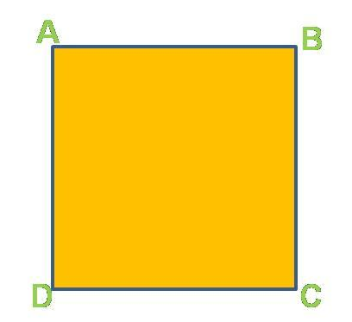
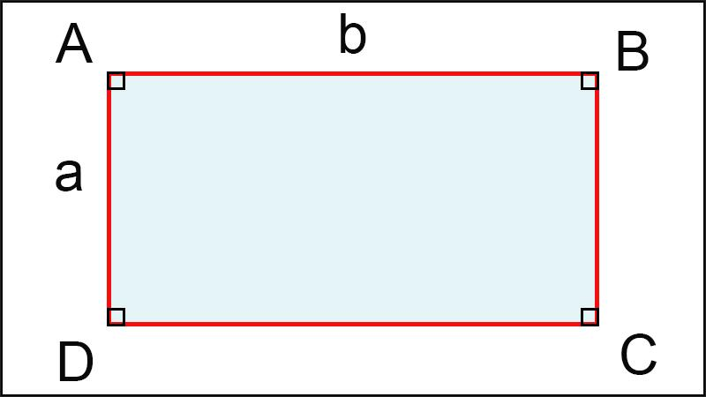
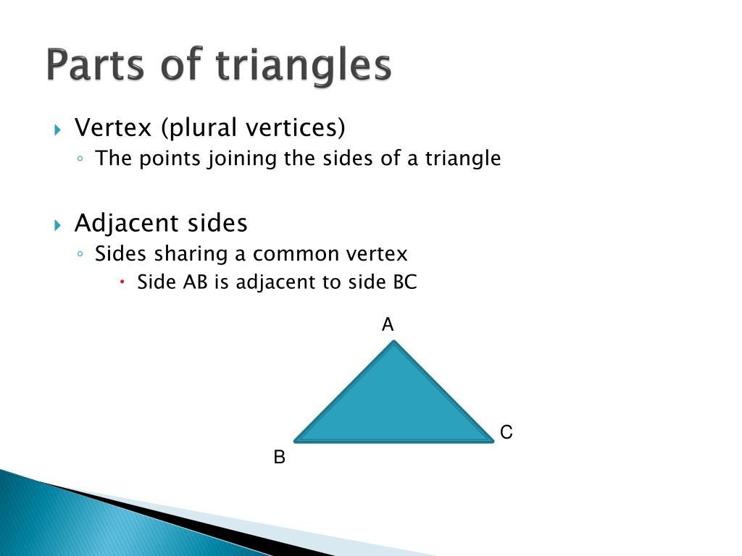
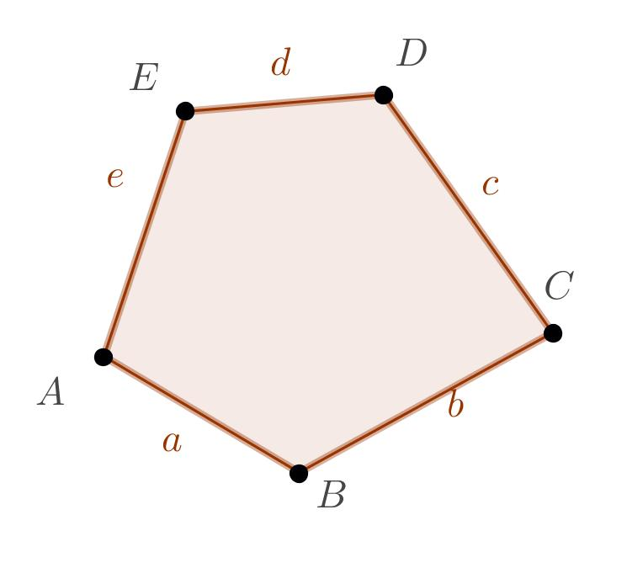

Definition
# Source: AI Source: Provided by: [Data Path: Persons Table -> ID Column: 1, Name_En Column: Motasem Essam] -> From: [ChatGPT] on [7/25/2026]
Adjacent Sides are two sides of a polygon that share a common vertex (endpoint). Because they meet at the same vertex, they are directly connected and together form one of the polygon's interior angles.
Every polygon has pairs of adjacent sides.

Characteristics
# Source: AI Source: Provided by: [Data Path: Persons Table -> ID Column: 1, Name_En Column: Motasem Essam] -> From: [ChatGPT] on [7/25/2026]
Adjacent sides:
- Share exactly one common vertex.
- Meet to form an interior angle.
- Are consecutive sides of the polygon.
- May be equal or unequal in length.
- Are different from opposite sides, which do not share a vertex.

Illustration

Square
# Source: AI Source: Provided by: [Data Path: Persons Table -> ID Column: 1, Name_En Column: Motasem Essam] -> From: [ChatGPT] on [7/25/2026]
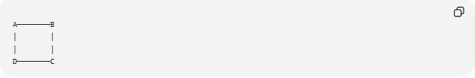
A────────B
│ │
│ │
D────────C
Adjacent side pairs:
- AB and BC
- BC and CD
- CD and DA
- DA and AB

Triangle
# Source: AI Source: Provided by: [Data Path: Persons Table -> ID Column: 1, Name_En Column: Motasem Essam] -> From: [ChatGPT] on [7/25/2026]
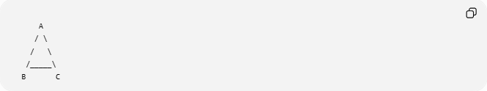
A
/ \
/ \
/_____\
B C
Adjacent side pairs:
- AB and AC
- AB and BC
- AC and BC
Each pair shares one vertex.

Mathematical Representation
# Source: AI Source: Provided by: [Data Path: Persons Table -> ID Column: 1, Name_En Column: Motasem Essam] -> From: [ChatGPT] on [7/25/2026]
If two sides share a common vertex:
$$\overline{AB}\text{ and }\overline{BC}$$
then they are adjacent sides because they meet at vertex
$$B$$

Examples
# Source: AI Source: Provided by: [Data Path: Persons Table -> ID Column: 1, Name_En Column: Motasem Essam] -> From: [ChatGPT] on [7/25/2026]
Example 1 – Rectangle
Adjacent sides:
$$\overline{AB}\text{ and }\overline{BC}$$
meet at vertex
$$B$$

Example 2 – Pentagon
In pentagon
$$ABCDE$$
Adjacent side pairs include:
$$\overline{AB}\text{ and }\overline{BC} \\ \overline{BC}\text{ and }\overline{CD}$$

Properties
# Source: AI Source: Provided by: [Data Path: Persons Table -> ID Column: 1, Name_En Column: Motasem Essam] -> From: [ChatGPT] on [7/25/2026]
1. Common Vertex
Adjacent sides always share one endpoint.

2. Form an Interior Angle
Every pair of adjacent sides creates one interior angle.
Example:
$$∠ABC$$
is formed by
$$\overline{AB}$$
and
$$\overline{BC}$$

3. Consecutive Order
Adjacent sides follow one another around the polygon.

4. May Be Equal or Unequal
Examples:
- Square → adjacent sides are equal.
- Rectangle → adjacent sides are generally unequal.
- Scalene triangle → adjacent sides may all have different lengths.

Real-World Examples
# Source: AI Source: Provided by: [Data Path: Persons Table -> ID Column: 1, Name_En Column: Motasem Essam] -> From: [ChatGPT] on [7/25/2026]
Adjacent sides appear in:
- Picture frames.
- Doors.
- Windows.
- Floor tiles.
- Books.
- Tables.
- Building walls.
- Road signs.
- Boxes.
- Smartphone screens.

Applications
# Source: AI Source: Provided by: [Data Path: Persons Table -> ID Column: 1, Name_En Column: Motasem Essam] -> From: [ChatGPT] on [7/25/2026]
Adjacent sides are used in:
- Plane Geometry
- Coordinate Geometry
- Engineering
- Architecture
- CAD (Computer-Aided Design)
- Computer Graphics
- Surveying
- Robotics
- Industrial Design

Advantages
# Source: AI Source: Provided by: [Data Path: Persons Table -> ID Column: 1, Name_En Column: Motasem Essam] -> From: [ChatGPT] on [7/25/2026]
Studying adjacent sides helps to:
- Identify interior angles.
- Classify polygons.
- Analyze geometric relationships.
- Solve perimeter problems.
- Construct geometric figures.

Limitations
# Source: AI Source: Provided by: [Data Path: Persons Table -> ID Column: 1, Name_En Column: Motasem Essam] -> From: [ChatGPT] on [7/25/2026]
Adjacent sides:
- Only exist in polygons.
- Cannot be defined for figures without vertices, such as circles.

Comparison with Related Concepts
# Source: AI Source: Provided by: [Data Path: Persons Table -> ID Column: 1, Name_En Column: Motasem Essam] -> From: [ChatGPT] on [7/25/2026]
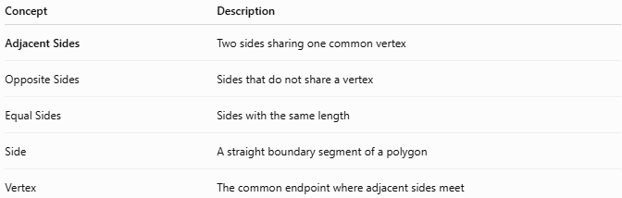
Concept | Description
Adjacent Sides | Two sides sharing one common vertex
Opposite Sides | Sides that do not share a vertex
Equal Sides | Sides with the same length
Side | A straight boundary segment of a polygon
Vertex | The common endpoint where adjacent sides meet

Key Points
# Source: AI Source: Provided by: [Data Path: Persons Table -> ID Column: 1, Name_En Column: Motasem Essam] -> From: [ChatGPT] on [7/25/2026]
- Adjacent Sides share one common vertex.
- They form an interior angle.
- They are consecutive sides of a polygon.
- Every polygon contains adjacent side pairs.
- Adjacent sides may be equal or unequal.

Conclusion
# Source: AI Source: Provided by: [Data Path: Persons Table -> ID Column: 1, Name_En Column: Motasem Essam] -> From: [ChatGPT] on [7/25/2026]
Adjacent Sides are two consecutive sides of a polygon that meet at a common vertex, forming one of the polygon's interior angles. They are fundamental for understanding the structure of polygons and the relationships between sides and angles. Adjacent sides are widely studied in plane geometry, coordinate geometry, engineering, architecture, CAD, computer graphics, surveying, robotics, and industrial design, where they are used to analyze shapes, construct geometric figures, and solve measurement problems.

